# DIGITAL NATURALIST- AI ENABLED TOOL FOR BIODIVERSITY RESEARCHES

*A Project report submitted in partial fulfillment of 7th semester in degree of*

BACHELOR OF ENGINEERING

IN

# COMPUTER SCIENCE AND ENGINEERING

***Submitted by***

Team ID: PNT2022TMID49866

|  |  |
| --- | --- |
| KARTHIKEYAN.L | 950619104029 |
| KATHIRAVAN.K | 950619104030 |
| MAHESH.V | 950619104036 |
| BALAJI.S | 950619104012 |



## DEPARTMENT OF COMPUTER SCIENCE AND ENGINEERING EINSTEIN COLLEGE OF ENGINEEING,

**TIRUNELVELI-627 012**

## BONAFIDE CERTIFICATE

Certified this Report **FOR ” DIGITAL NATURALIST -AI ENABLED TOOL BIODIVERSITY RESEARCHES”**, for the project, is the bonafied work of **Mr.KARTHIKEYAN.L(950619104029),Mr.KATHIRAVAN.K(950619104030),Mr.MAHESH.V(950619104036),Mr.BALAJI.S(950619104012)** who carried out the project work under my supervision. Certified further that to the best of my knowledge the work reported here in does not form part of any other thesis or dissertation on the basis of which a degree or award was co-offerred on the earlier occasion on this or any other candidate.

## SIGNATURE SIGNATURE

**Dr. T.SURESH THANKRISHNAN Mr.s S.JEYAMARY**

**HEAD OF THE DEPARTMENT MENTOR**

**COMPUTER SCIENCE AND ENGINEERING COMPUTER SCIENCE AND ENGINEERING EINSTEIN COLLEGE OF ENGINEEING EINSTEIN COLLEGE OF ENGINEERING TIRUNELVELI-12 TIRUNELVELI-12**

**ACKNOWLEDGEMENT**

We have successfully completed the project with blessings showered onus by god, the almighty, A project of this nature needs co-operation and support from many for successful completion.

We express our heartfelt thanks to **Mr.A.MATHIVANAN, BE., M.sc.,(Agri),** Managing Trustee of Einstein college of Engineering, Tirunelveli, for his mortal support and device.

Our thanks to **Prof.A.AMUTHAVANAN, BE., M.S (USA).B.L,**Chairman of our college for making necessary arrangements to do this project.

Our heartly thanks to **Prof.EZHILVANAN, MBA.,** Secretary of our college for making necessary arrangements to do this project.

We wish to express our gratitude to **Dr.VELAYUTHAM,M.E,Ph.D.,FIE.** Principal for the support he provided us to carry out this project successfully.

We are very much thankful to **Dr. T.SURESH THANKRISHNAN**, Head of the Department , Department of computer science and engineering who is always a constant of inspiring us.

**We are extend our sincere thanks to all teaching and non-teaching staff members and our family members, friends for their help in completing this project.**

**TABLE OF CONTENTS**

**CHAPTER NO TITLE PAGE NO**

**ABSTRACT**

**LIST OF FIGURES**

**LIST OF TABLES**

**1 INTRODUCTION**

1.1 Project Overview

1.2 Purpose

**2 LITERATURE SURVEY**

2.1 Existing problem

2.2 References

**3 IDEATION & PROPOSED SOLUTION**

3.1 Empathy Map Canvas

3.2 Ideation & Brainstorming

3.3 Proposed Solution

3.4 Problem Solution fit

**4. REQUIREMENT ANALYSIS**

4.1 Functional requirement

4.2 Non-Functional requirements

**5. PROJECT DESIGN**

5.1 Data Flow Diagrams

5.2 Solution & Technical Architecture

5.3 User Stories

**6. PROJECT PLANNING & SCHEDULING**

6.1 Sprint Planning & Estimation

6.2 Sprint Delivery Schedule

6.3 Burndown Chart

**7. CODING & SOLUTIONING**

7.1 Feature 1

7.2 Feature 2

**8. TESTING**

8.1 Test Cases

8.2 User Acceptance Testing

**9. RESULTS**

9.1 Performance Metrics

**10.**  **ADVANTAGES & DISADVANTAGES**

**11. CONCLUSION**

**12. FUTURE SCOPE**

**13. APPENDIX Source Code GitHub & Project**

**Demo Link**

**LIST OF FIGURES**

**FIG.NO FIG.NAME PAGE.NO**

**3.1.1 Empathy map canvas**

**3.2.2 Brain Storming**

**5.1.1 Data flow diagrams**

**5.2.1 Technical Architecture**

**5.3.1 User Stories**

**6.3.1 Burndown Chart**

**LIST OF TABLES**

**TAB.NO TAB.NAME TAB.PAGE**

**3.3.1 Proposal Solution**

**Functional Requirements**

**Non Functional Requirements**

**Sprint Planning and Estimation**

**Sprint Delivery Schedule**

**CHAPTER-1**

**1.INDRODUCTION**

* 1. **project overview**

A naturalist is someone who studies the patterns of nature, identifies a different kind of flora and fauna in nature. Being able to identify the flora and fauna around us often leads to an interest in protecting wild spaces, and collecting and sharing information about the species we see on our travels is very useful for conservation groups like NCC.

When venturing into the woods, field naturalists usually rely on common approaches like always carrying a guidebook around everywhere or seeking help from experienced ornithologists. There should be a handy tool for them to capture, identify and share the beauty to the outside world.

Field naturalists can only use this web app from anywhere to identify the birds, flowers, mammals and other species they see on their hikes, canoe trips and other excursions.

In this project, we are creating a web application which uses a deep learning model, trained on different species of birds, flowers and mammals (2 subclasses in each for a quick understanding)and get the prediction of the bird when an image is been given.

* 1. **Purpose**

**By the end of this project you’ll understand:**

1.Augmenting a dataset to virtually increase the size of small datasets in order to make our machine learning models work better

2.Preprocess the images to a machine-readable format.

3.Applying CNN algorithm on the dataset.

4.How deep neural networks are predicting the class and subclass of a given image.

5.You will be able to know how to find the accuracy of the model.

6.You will be able to build web applications using the Flask framework.

CHAPTER-2

1. **Literature survey**
   1. **Existing Problem**

**Problem Statement:**

1. Karthi need a way to identifies a different kind of flora and

fauna in nature.

2. Mahesh need a way to creating a web application which uses

a deep learning model.

3. Balaji need a way to interest in protecting wild spaces

endangered animals.

4. Kathir need a way to collecting and sharing information

about species.

5. Mary said that our travels is very useful for conservation

groups like NCC.

* 1. **Reference**
* **REVIEW-1:**
* **Title of the Paper:**

Digital Naturalist Using Deep Learning

* **Name of the Author:**

Aparna, SaloniM, ChandanaM , NehaU, BanushreeDJ ,Prof.NareshPatelK M

Department of Computer Science and Engineering, BIETD avanagere

* **Problem Description:**

A naturalist is someone who studies the patterns of nature identify different kingdom of flora and fauna in the nature.Being able to identify the flora and fauna around us often leads to an interest in protecting wild species, collecting and sharing information about the species we see on our travels is very useful for conserving groups like NCC. Deep-learning based techniques and methods are becoming popular in digital naturalist studies, as their performance is superior in image analysis

fields, such as object detection, image classification, and semantic segmentation.Deep-learning techniques have achieved state

of-the -art performance for automatic segmentation of digital naturalist through multi-model image sensing. Our task as naturalist has grown widely in the field of natural-historians. It has increased from identification to saviours as well. Not only identifying flora and fauna but also to know about their habits,habitats, living and grouping lead to fetching services for protection as well.

* REVIEW-2:
* **Title of the Paper:**

AI Naturalists Might Hold the Key to Unlocking Biodiversity Detain Social Media Imagery

* **Name of the Author:**

Tom A. August, Oliver L. Pescott,AlexisJoly,PierreBonnet

* **Problem Description**:

The increasing availability of digital images, coupled with sophisticated artificial intelligence (AI) techniques for image classification, presents an exciting opportunity for biodiversity researchers to create new datasets of species observations. We investigated whether an AI plant species classifier could extract previously unexploited biodiversity data from social media photos(Flickr).Wefoundover60,000geolocatedimagestagged with the keyword ‘‘flower’’ across an urban and rural location in the UKand classified these using AI,reviewing these identifications and assess in there presentation of images.

Images were predominantly biodiversity focused, showing single species. Non-native garden plants dominated,particularly in the urban setting. The AI classifier performed best when photos were focused on single native species in wild situations but also performed well at higher taxonomic levels (genus andfamily), even when images substantially deviated from this. Wepresent a checklist of questions that should be considered when undertaking a similar analysis

* REVIEW-3:
* **Title of the Paper:**

Digital Naturalist Design Guidelines: Theory, Investigation,Development, and Evaluation of a Computational Media Framework to Support Ethological Exploration

* **Name of the Author:**

Andrew Quitmeyer

National University of Singapore Singapore

[andy@quitmeyer.org](mailto:andy@quitmeyer.org)

* **Problem Description:**

This research aims to develop and evaluate a design framework for creating digital devices that support the exploration of animal behaviors in the wild. This paper quickly shares the main concepts and theories from the fields forming Digital Naturalism’s foundation while presenting the key challenges emerging from these critical intersections between field biology and computational media. It then reviews the development of this research’s hybrid methodology designed specifically for its multi-year series of “Qualitative Action Research” field work carried out at a rainforest field station. This paper analyzes the resulting on-site ethnographies, workshops, design projects, and interactive performances, whose take-aways are synthesized into design guidelines for digital-natural media. This framework,itself,is then evaluated via an extra iteration of field work and the results discussed. Finally,the paper identifies targets for

continued research development. Further areas of interest are presented which will promote Digital Naturalism’s progression into its own topic of study

* REVIEW-4:
* **Title of the Paper:**

From Digital Nature Hybrids to Digital Naturalists: Reviving Nature Connections Through Arts, Technology and Outdoor Activities

* **Name of the Author:**

L.Edwards, A.Darby,and C.Dean

* **Problem Description**:

Thisworkconsidershowtheartsandtechnologyincombination can stimulate connections in heritage gardens, and also nurture care for non-human nature.The chapter divides into two overlapping parts. The first part describes and critiques the design of Digital Nature Hybrid artifacts for interpreting garden sand exploring nature. The second part builds on the first by showing how the challenges presented by the Digital Nature Hybrids stimulated the design of Digital Naturalist workshops.It shows the value of combining arts, digital technologies and outdoor activities to support active engagements with non-human nature and to inspire the development of knowledge and

skills needed to attend to natural environments. Research through design underpins the way of working and the project uses a critical approach toward technology, to guide the design decisions. One of the insights is the value that adopting this critical approach has in shaping both processes and designs.

* REVIEW-5:
* **Title of the Paper:**

Digital Naturalism: Inter species Performative Tool Making for Embodied Science

* **Name of the Author:**

Andrew Quitmeyer

Digital Media PhD Student Georgia Institute of Technology85FifthStreet

Atlanta,GA30308USA[andy@quitmeyer.org](mailto:andy@quitmeyer.org)

* **Problem Description:**

Digital Naturalism investigates the role that digital media can play in field Ethology. While digital technology plays an increasingly larger role in the Ethologist’s process, its use tends to be limited to the experimentation and analysis stages.My

goal is to work with scientists to develop context-dependent,behavioral tools promoting novel interactions between animal,man, and environment. The aim is to empower the early exploratory phases of their research as well as the later representation of their work. I will test a methodology combining analytical tool making and interaction studies with modern methodology.

CHAPTER-3

**3 IDEATION AND PROPOSED SOLUTION**

**3.1 Empathy map canvas:**

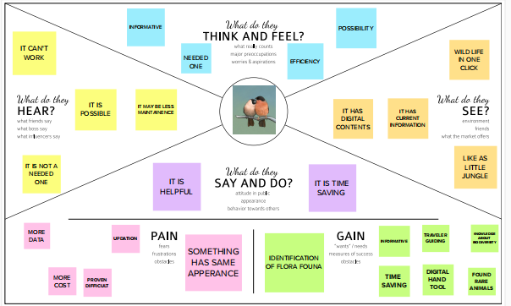

**3.2 Brainstorming**

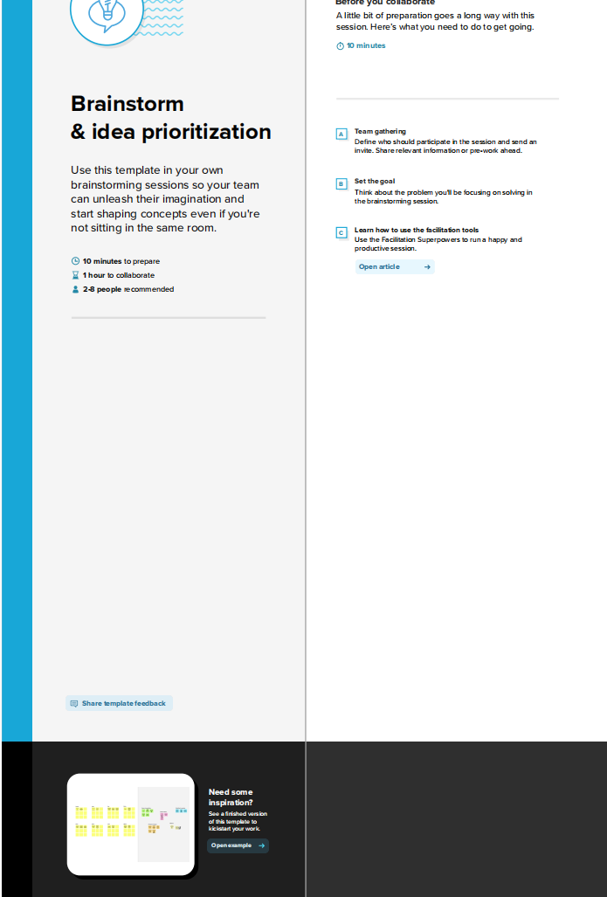

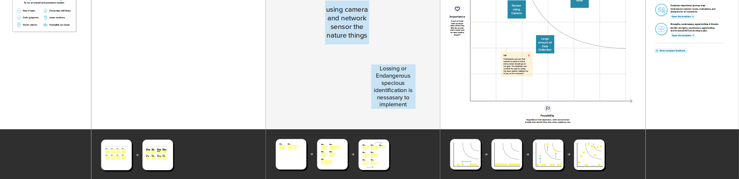

**3.3 Proposed solution**

|  |  |  |
| --- | --- | --- |
| **S.No.** | **Parameter** | **Description** |
|  | Problem Statement (Problem to be solved) | Wants to create A handy guide book that contains information about nature and biodiversity and need an application for knowing about biodiversity. |
|  | Idea / Solution description | Creating a web application that gives a clear information of biodiversity . |
|  | Novelty / Uniqueness | We are using web application and sense the images by camera by using the technology artificial intelligence . |
|  | Social Impact / Customer Satisfaction | It gives clear information about endangered a animals.so its give a valuable impact in protecting such animals. |
|  | Business Model (Revenue Model) | We need to develop a website to login customer.we can earn by the website by giving information that the customer need. |
|  | Scalability of the Solution | Our solution is functional when adding new data to enhance the system |

**3.4 problem Solution Fit**

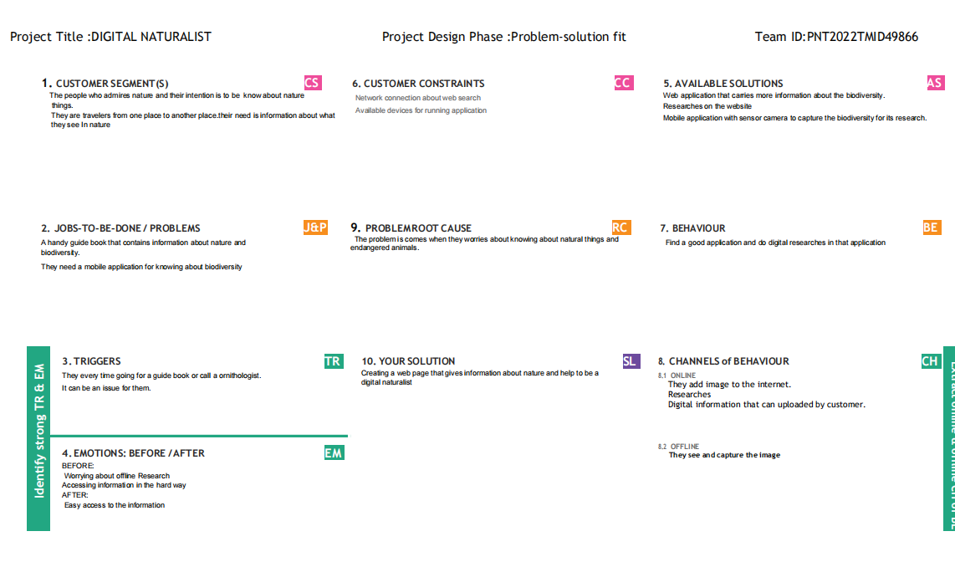

**CHAPTER-4**

**REQUIRMENT ANALYSIS**

**4.1 Functional Requirements**

|  |  |  |
| --- | --- | --- |
| **FR No.** | **Functional Requirements(Epic)** | **Non-Functional Requirements(sub-tasks)** |
| FR-1 | Authentication | Username  Password |
| FR-2 | Authorization levels | User  Administrator |
| FR-3 | External Interfaces | Camera  Hard disk  Adopter drive |
| FR-4 | Demo | Pictures |
| FR-5 | Reporting | If you see some information is confused to know the truth |
| FR-6 | Historical Data | The Server Automatically backup the database every 24 hours |
| FR-7 | Feedback | Through command |

**4.2 Non-Functional Requirements**

|  |  |  |
| --- | --- | --- |
| **NFR no.** | **Non Functional Requirements** | **Descriptions** |
| NFR -1 | Usability | Very easy to use the application in any operating system.simple layout if the system gives easy access of all the functions of the application. |
| NFR-2 | Security | The system should require users to enter their password every login.  Unauthorized access is denied. |
| NFR-3 | Availability | The system functions anytime.when you need you can use it. |
| NFR-4 | Scalability | Registration can be done in any time |
| NFR-5 | Performance | User can quickly get the information.  The information data server is fast |
| NFR-6 | Reliability | Its is very informative when you give easy identifiable figures. |
| NFR-7 | Capacity | Less volume |

**CHAPTER-5**

1. **Project Design**
   1. **Data flow diagrams**

Data Flow Diagrams:

A Data Flow Diagram is a traditional visual representation of the information system. A neat and clear DFD can depict the right amount of the system requirement graphically.

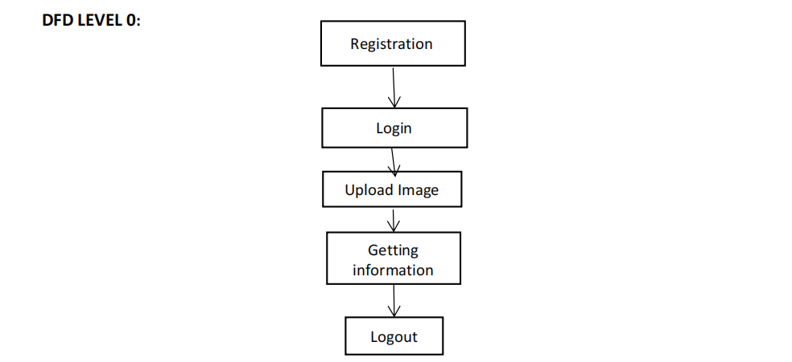

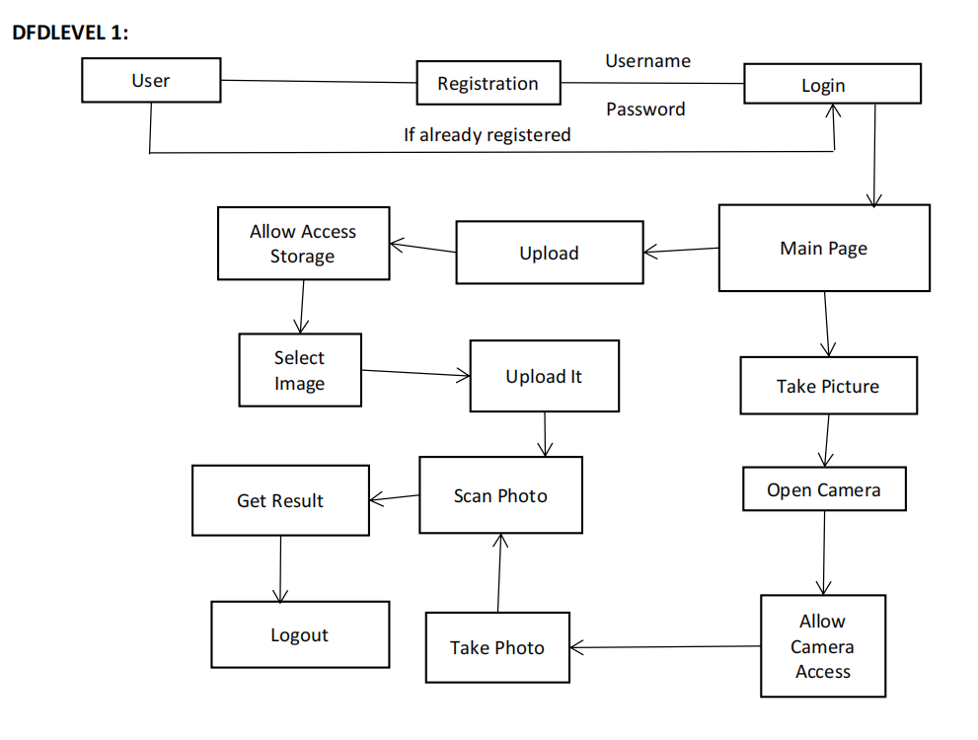

* 1. **Solution and Technical Architecture**

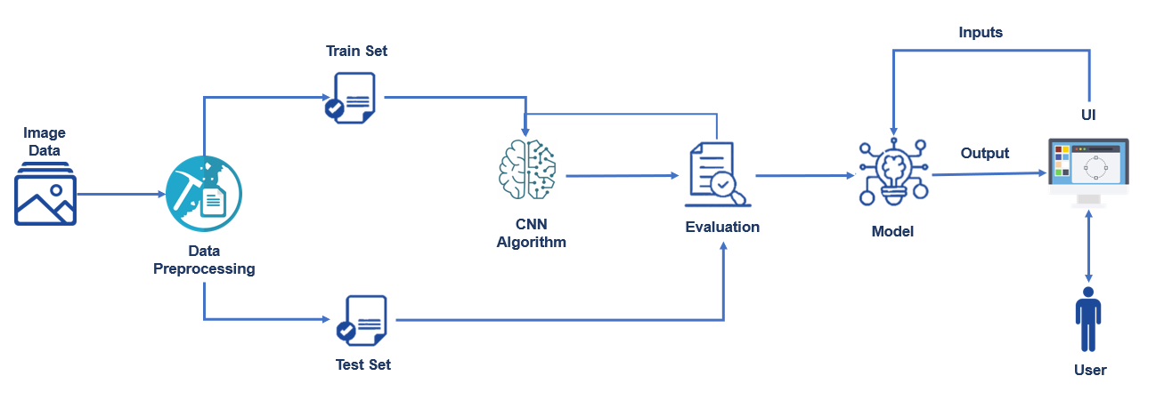

* 1. **User Stories**

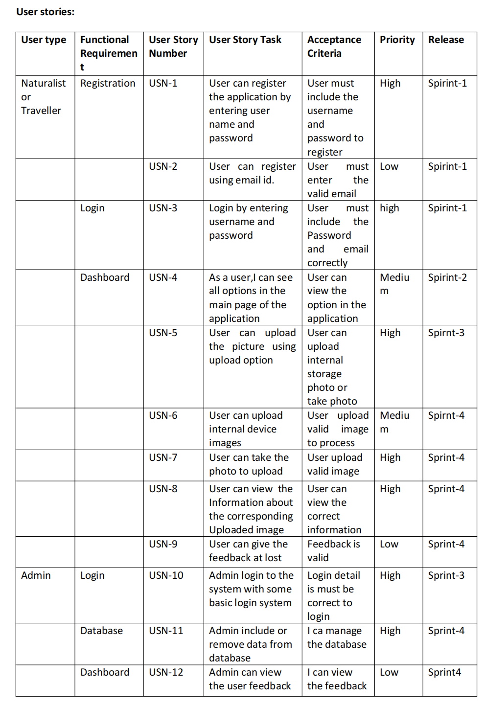

CHAPTER-6

**6 Project Planning And Scheduling**

**6.1 Sprint Planning And Estimation**

Use the below template to create product backlog and sprint schedule

|  |  |  |  |  |  |  |
| --- | --- | --- | --- | --- | --- | --- |
| Sprint | Functional Requirement(Epic) | User story | User Story/Task | StoryPoints | Priority | TeamMe mbers |
| Sprint-1 | Registration | USN-1 | As a user , I can register for the application by entering my email, password. | 2 | High |  |
| Sprint-1 |  | USN-2 | As a user I will receive confirmation email once I have registered for the application | 1 | High |  |
| Sprint-1 |  | USN-3 | As a user, I can register for the application through Gmail | 2 | Medium |  |

**Product Backlog, Sprint Schedule, and Estimation (4 Marks)**

|  |  |  |  |  |  |  |
| --- | --- | --- | --- | --- | --- | --- |
| **Sprint** | **Functional Requirement (Epic)** | **User Story Number** | **User Story / Task** | **Story Points** | **Priority** | **Team Members** |
| Sprint-1 | Registration | USN-1 | As a user, I can register for the application by entering my username l, password, and confirming  my password. | 3 | High | Kathiravan |
| Sprint-1 | Registration | USN-2 | As a user, I will receive confirmation email once I have registered for the application | 2 | High | Balaji |
| Sprint-1 | Login | USN-3 | As a user, I can log into the application by entering username & password | 1 | Low | mahesh |
| Sprint-2 | upload | USN-4 | As a user, I can upload the picture to knowing about it | 3 | Medium | karthikeyan |
| Sprint-2 | Select file | USN-5 | As a user,I can select picture in my device | 8 | High | karthikeyan |
| Sprint-3 | Take photo | USN-6 | As a user, I can take photo from device camera | 3 | High | Balaji |
| Sprint-3 | information | USN-7 | As a user, I can get the information bout what we upload | 2 | Medium | Balaji |
| Sprint-4 | Administration | USN-8 | As a user, I can monitor the logs and other data | 5 | High | kathirava n |
| Sprint-4 | Logout | USN-9 | As a user, I can logout from the dashboard | 1 | Low | mahesh |

**6.2 Sprint Schedule Delivery**

Project Tracker,Velocity& Burn down Chart:

|  |  |  |  |  |  |  |
| --- | --- | --- | --- | --- | --- | --- |
| **Sprint** | **TotalStory Points** | **Duration** | **Sprint Start Date** | **Sprint End Date( Planned)** | **Story Points Completed(as on Plan ed End Date)** | **Sprint Release Date( Actual)** |
| Sprint-1 | 20 | 6Days | 24Oct2022 | 29Oct2022 | 20 | 29Oct2022 |
| Sprint-2 | 20 | 6Days | 31Oct2022 | 05Nov2022 | 20 | 05Nov2022 |
| Sprint-3 | 20 | 6Days | 07Nov2022 | 12Nov2022 | 20 | 12 Nov2022 |
| Sprint-4 | 20 | 6Days | 14Nov2022 | 19Nov2022 | 20 | 19 Nov 2022 |
|  |  |  |  |  |  |  |

**Chapter-7**

**7.Coding And Solutioning**

**7.1 Feature 1**

**Convolution Neural network Model Building**

**Coding:**

HTML Web page:

<!DOCTYPE html>

<html lang="en">

<head>

<meta charset="UTF-8">

<meta name="viewport" content="width=device-width, initial-scale=1.0">

<meta http-equiv="X-UA-Compatible" content="ie=edge">

<title>DIGITAL NATURALIST</title>

<meta name="description" content="">

<meta name="keywords" content="">

<link rel="icon" type="image/x-icon" href="https://img.icons8.com/fluency/48/000000/natural-food.png">

<link href="https://fonts.googleapis.com/css?family=Source+Sans+Pro:400,700" rel="stylesheet">

<link rel="stylesheet" href="/static/style.css">

</head>

<body class="leading-normal tracking-normal text-gray-900" style="font-family: 'Source Sans Pro', sans-serif;">

<div class="h-screen pb-14 bg-right bg-cover">

<!--Nav-->

<div class="w-full container mx-auto p-6">

</div>

<!--Main-->

<div class="container pt-24 md:pt-48 px-6 mx-auto flex flex-wrap flex-col md:flex-row items-center">

<!--Left Col-->

<div class="flex flex-col w-full xl:w-2/5 justify-center lg:items-start overflow-y-hidden">

<h1

class="my-4 text-3xl md:text-5xl text-green-800 font-bold leading-tight text-center md:text-left slide-in-bottom-h1">

Digital Naturalist Using CNN</h1>

<p class="leading-normal text-base md:text-2xl mb-8 text-center md:text-left slide-in-bottom-subtitle">

AI Enabled Tool For Biodiversity Reacherces</p>

<p>To find animal bird and flower</p>

<div class="flex w-full justify-center md:justify-start pb-24 lg:pb-0 fade-in">

<form action="/predict" id="upload-file" method="post" enctype="multipart/form-data">

<input type="file" name="uploadedimg" id="uploadedimg" required accept=".jpg, .png, .jpeg, .gif, .bmp, .tif, .tiff|image/*" >

<br><br> <input type="reset" value="Reset" class="upload">

<input type="submit" value="Upload" class="upload" onsubmit="check_file style="color:blue"><br>

</form>

</div>

</div>

<!--Right Col-->

<div class="w-full xl:w-3/5 py-6 overflow-y-hidden"><br>

<img src="animal.jpg">

</div>

<!--Footer-->

<div class="w-full pt-16 pb-6 text-sm text-center md:text-left fade-in">

<a class="text-gray-500 no-underline hover:no-underline"

href="https://github.com/IBM-EPBL/IBM-Project-46326-1660745221">&copy; Digital Naturalist</a>

</div>

</div>

</div>

<script>

document.getElementById("uploadedimg").addEventListener("change", validateFile)

function validateFile(){

const allowedExtensions = ['jpg','png'],

sizeLimit = 1_000_000;

const { name:fileName, size:fileSize } = this.files[0];

const fileExtension = fileName.split(".").pop();

if(!allowedExtensions.includes(fileExtension)){

alert("Only image files - .jpg, .jpeg, .png, .tiff ");

this.value = null;

}else if(fileSize > sizeLimit){

alert("file size too large")

this.value = null;

}

}</script>

</body>

</html>

**7.2Feature 2**

Flask Building:

from flask import Flask, redirect, render_template, request

app = Flask(__name__)

@app.route('/', methods=['GET'])

def index():

# Home Page

return render_template("index.html")

@app.route('/predict', methods=['GET', 'POST'])

def upload():

# logic yet to be built

if request.method == 'GET':

return ("Here the logic is defined")

if request.method == 'POST':

return ("Here the logic is defined")

if __name__ == '__main__':

app.run()

Webpage view:

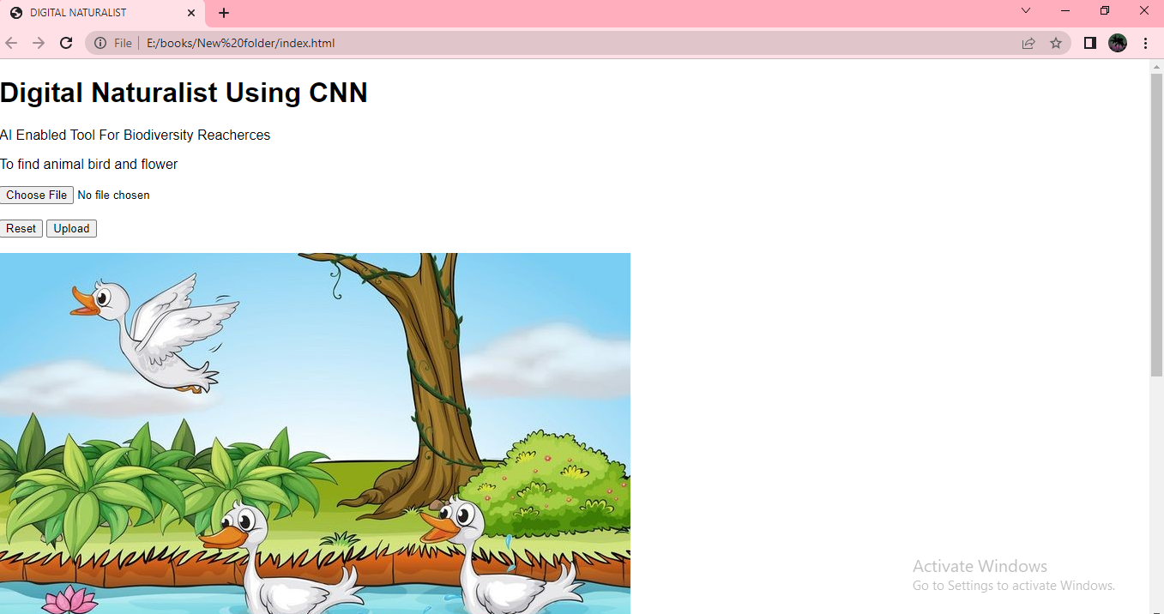

CNN Model Building

Convolutional Neural Network(CNN) is a type of advanced artificial neural network. A CNN consists of an input and an output layer, as well as multiple hidden layers. The hidden layers of a CNN typically consist of convolutional layers, pooling layers, fully connected layers and normalization layers.

Before diving into the Convolution Neural Network, let us first revisit some concepts of Neural Network. In a regular Neural Network there are three types of layers:

Input Layers: It’s the layer in which we give input to our model. The number of neurons in this layer is equal to the total number of features in our data (number of pixels in case of an image).

Hidden Layer: The input from the Input layer is then fed into the hidden layer. There can be many hidden layers depending upon our model and data size. Each hidden layer can have different numbers of neurons which are generally greater than the number of features. The output from each layer is computed by matrix multiplication of output of the previous layer with learnable weights of that layer and then by the addition of learnable biases followed by activation function which makes the network nonlinear.

Output Layer: The output from the hidden layer is then fed into a logistic function like sigmoid or softmax which converts the output of each class into a probability score of each class.

The data is then fed into the model and output from each layer is obtained; this step is called feedforward.

Then calculate the error using an error function, some common error functions are cross-entropy, square loss error etc

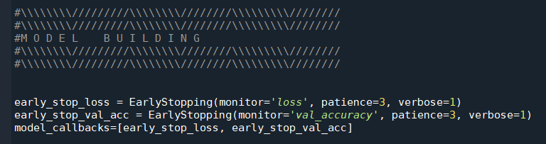

**Add Layers ( Conv, Maxpool, Flatten, Dense, Dropout)**

Strides decide how our weight matrix should move in the input, i.e jumping one step or two.

Padding amount of pixels added to an image when it is being processed by the kernel of a CNN

Max Pooling selects the maximum element from the region of the feature map covered by the filter. Thus, the output after the max-pooling layer would be a feature map containing the most prominent features of the previous feature map.

Dropout Layer : Dropout works by probabilistically removing, or “dropping out,” inputs to a layer, which may be input variables in the data sample or activations from a previous layer. It has the effect of simulating a large number of networks with very different network structure and, in turn, making nodes in the network generally more robust to the inputs.

Dropout refers to dropping (not considering in both forward and backward pass) some neurons during the training phase. The neurons which are chosen at random.

Fully Connected essential component of Convolutional Neural Networks (CNNs), which have been proven very successful in recognizing and classifying images for computer vision. layers where all the inputs from one layer are connected to every activation unit of the next layer. Fully connected layer that interprets the features extracted by the convolutional part of the model has to Flatten and connected to the output layer, that’s what fully connected does, it flattens. It is also called the dense layer.

Flatten layer is used between the convolutional layers and the dense layer to reduce the feature maps to a single one-dimensional vector.

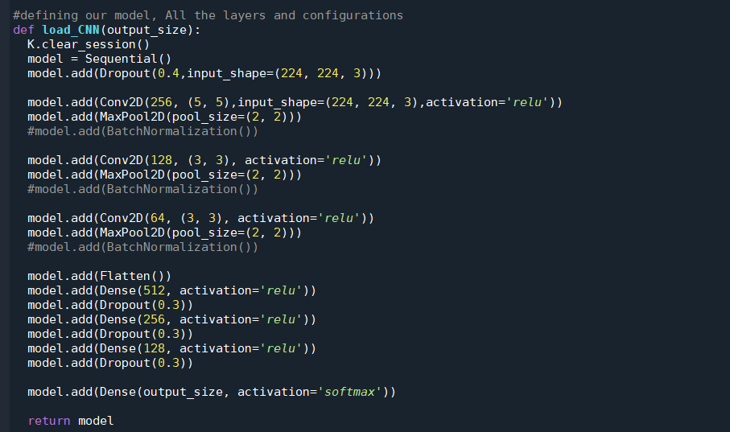

**Building Model (Summary, Compile, Fit, Predict )**

In this example, we define a convolutional layer with filter maps and kernels. This is followed by a max pooling layer and a dense layer to interpret the input feature. An output layer is specified that predicts a single numerical value.

The model is fit using the efficient Adam version of stochastic gradient descent and optimized using the mean squared error, or ‘mse‘, loss function.

Once the model is defined, we can fit it on the training dataset.

The model expects the input shape to be three-dimensional with [samples, timesteps, features], therefore, we must reshape the single input sample before making the prediction.

Model Summary : model.summary() is used to see all parameters and shapes in each layer in our model.

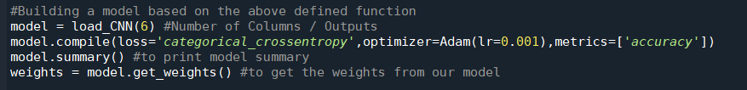

**Fitting Model** : After compiling our model, we will train our model by the fit() method, then evaluate it.

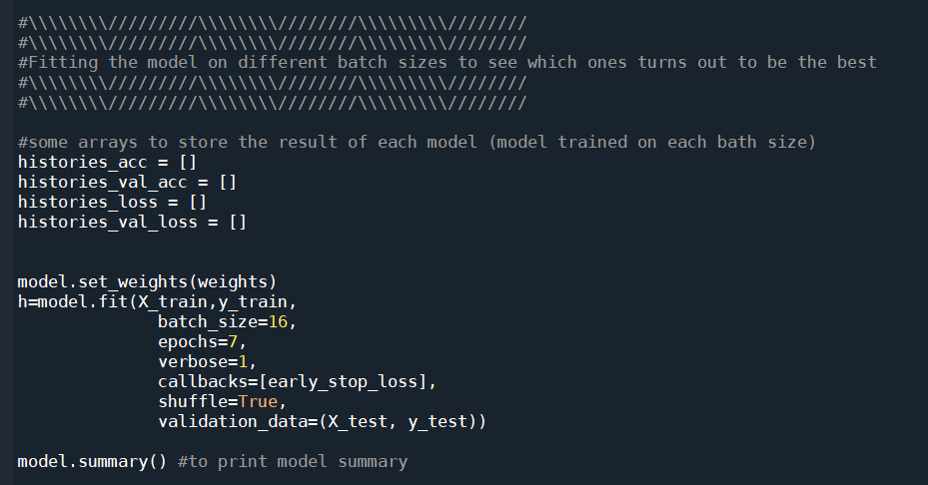

CHAPTER-8

**8 TESTING**

**8.1 Test Cases**

|  |  |  |  |  |  |  |  |  |  |  |  |  |  |
| --- | --- | --- | --- | --- | --- | --- | --- | --- | --- | --- | --- | --- | --- |
|  | | | | Date | 17-Nov-22 |  | | | | | | | |
| Team ID | PNT2022TMID49866 |
| Project Name | Project - Digital Naturalist - AI Enabled tool for Biodiversity Researchers |
| Maximum Marks | 4 marks |
| **Test case ID** | **Feature Type** | **Component** | **Test Scenario** | **Pre-Requisite** | **Steps To Execute** | **Test Data** | **Expected Result** | **Actual Result** | **Status** | **Commnets** | **TC for Automation(Y/N)** | **BUG**  **ID** | **Executed By** |
| Webpage_TC_001 | UI | Home Page | Verify the user is able to view the page | 1. Latest web browser 2. Proper Internet Connection | 1. Enter the url of the website and click go 2. Verify the webpage is loading or not | no test data required | The webpage should be visible to the user | The webpage is visible | Pass | The test case passed without any issues | Y | 1 | Gokul R |
| Webpage_TC_002 | UI | Home Page | Verify the page is responsive for all devices | 1. Mobile device 2. Desktop device 3. Tablet device 4. Webbrowser and internet connection | 1. Enter the url of the website and click go 2. Verify the webpage is loading properly with proper alignments in all the devices | no test data required | The webpage should be visible to the user | The webpage is visible in all the devices | Pass | The test case passed without any issues | Y | 2 | Dinesh Kumar T |
| Webpage_TC_003 | UI | Home Page | Verify the UI elements in upload work | 1. Latest web browser 2. Proper Internet Connection | 1. Enter the url of the website and click go 2. After tha page loaded Successfully click the upload button | Sample Species's images for testing | The webpage should accept the image from the user | The webpage accepts the user input | Pass | The test case passed without any issues | Y | 3 | Baranidharan N |
| Webpage_TC_004 | UI | Home Page | Verify the page is responding for every user action | 1. Latest web browser 2. Proper Internet Connection | 1. Enter the url of the website and click go 2. Verify the webpage is loading and working properly during the upload and reset | Sample Species's images for testing | The webpage should be stable during the upload and predicting procedure | The webpage is responding stably | Pass | The test case passed without any issues | Y | 4 | Abishek S |
| Webpage_TC_005 | UI | Home Page | Verify the app accepts only image formats | 1. Latest web browser 2. Proper Internet Connection | 1. Enter the url of the website and click go 2. After page loading try to upload non image formats such as pdf, xml, or any audio or video file | non image data | The webpage should reject the user input and promts the user to upload proper image data for predecting | The webpage prompted with an error message when wrong filetype is uploaded | Pass | The testcase passed without any issues | Y | 5 | Gokul R |
| Flask_TC_001 | Functional | Flask app | Verify the flask app use the saved model | 1. Latest web browser 2. Proper Internet Connection | 1. Enter the url of the website and click go 2. Verify the webpage is accepting inputs and predecting according to the category of the animal | Sample Species's images for testing | The webapp should predict the animal properly | The webapp predicts the animal accurately | Pass | The test case passed without any issues,  but it requires more dataset to predict the animal accuretly | Y | 6 | Gokul R |
| Flask_TC_002 | Functional | Flask app | Verify the uploaded image saved on the server | 1. Latest web browser 2. Proper Internet Connection 3. Storage in the server for storing the uploaded image | 1. Enter the url of the website and click go 2. After page loading try to upload the image and wait | Sample Species's images for testing | The website should accept the image data and save it locally on the server | The app stored the image successfully | Pass | The testcase passed without any issues, But storage will be a issue in future when the storage overflowerd | Y | 7 | Jagan P |
| Flask_TC_003 | Functional | Flask app | Verify the uploaded image can be retrived from the storage | 1. Latest web browser 2. Proper Internet Connection 3. Storage in the server where the uploaded image can be retrived | 1. Enter the url of the website and click go 2. Verify the webpage is accepting inputs and predecting according to the category of the animal | Sample Species's images for testing | The web app should be able to store and retrive the image that is uploaded by the user | The app retrived the image successfully | Pass | The testcase passed without any issues. | Y | 8 | Dinesh Kumar T |
| Flask _TC_004 | Functional | Flask app | Verify the app redirects the user to appropriate species's wikipedia page after predecting | 1. Latest web browser 2. Proper internet connection 3. Sample Species's images to test | 1. Enter the url of the website and click go. 2. Verify the page is redirecting to appropriate specie's webpage | Sample Species's images for testing | The web app should redirect to the appropriate species's wikipedia | The app redirected successfully | Pass | The testcase passed without any issues | Y | 9 | Abishek S |

**8.2 User Acceptance Testing**

Purpose of Document

The purpose of this document is to briefly explain the test coverage and open issues of the Digital Naturalist project at the time of the release to User Acceptance Testing (UAT).

Defect Analysis

This report shows the number of resolved or closed bugs at each severity level, and how they were resolved

|  |  |  |  |  |
| --- | --- | --- | --- | --- |
| Resolution | Low Severity | Medium Severity | High Severity | Subtotal of bugs |
| By UI | 1 | 2 | 2 | 5 |
| By Functionality | 0 | 2 | 2 | 4 |
| Duplicate | 0 | 4 | 7 | 11 |
| External | 0 | 0 | 0 | 0 |
| Fixed | 1 | 4 | 4 | 9 |
| Not Reproduced | 0 | 0 | 0 | 0 |
| Skipped | 0 | 0 | 0 | 0 |
| Won't Fix | 0 | 0 | 0 | 0 |
| Totals | 2 | 16 | 15 | 29 |

**CHAPTER-9**

**9 RESULTS**

**9.1 Performance Matrices**

Model Performance Testing:

Project team shall fill the following information in model performance testing template.

|  |  |  |  |
| --- | --- | --- | --- |
| S.No. | Parameter | Values | Screenshot |
| 1. | Model Summary | Total params: 22,109,990  Trainable params: 307,206  Non-trainable params: 21,802,784 | Screenshot 1 |
| 2. | Accuracy | Training Accuracy - 92.8%  Validation Accuracy - 85.6% | Screenshot 2 |

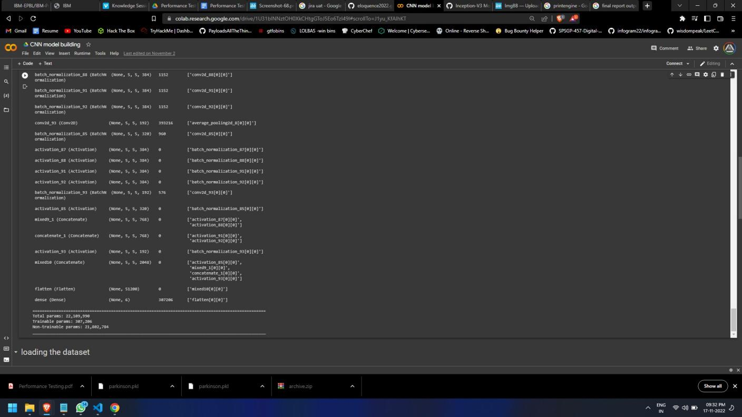

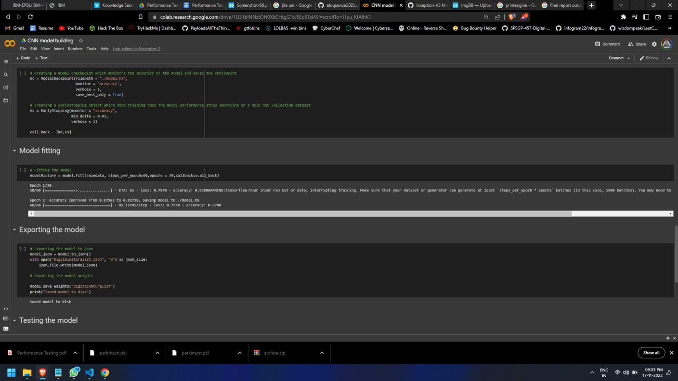

**CHAPTER-10**

**10 ADVANTAGES AND DISADVANTAGES**

**ADVANTAGES:**

Recent reports of global biodiversity decline make it more important than ever to

monitor biodiversity so that we can detect changes and infer their drivers. Online digital media, such as social media images, may be a new source of biodiversity observations, but they are far too numerous for a human to practically review. In this paper we apply an AI image classifier, designed to identify plants from images, to social media imagery to assess this method as a way to generate new biodiversity observations. We find that this approach is able to generate new data on species occurrence but that there are biases in both the social media data and the AI image classifier that need to be considered in analyses. This

approach could be applied outside the biodiversity domain, to any phenomena of interest that may be captured in social media imagery. The checklist we provide at the end of this paper should therefore be of interest to anyone considering this approach to generating new data.

**DISADVANTAGES**

The initial Digital Nature Hybrid designs went some way to revealing places and

showing non-human nature in a new light. It demonstrated how digital technologies

could be rooted in context and culture and how they could amplify particular sensory

stimuli to resonate with the sense of place. This in itself had value, for designers,

organization and visitors.

**CHAPTER-11**

**CONCLUSION**

This work consider show the arts and technology in combination can stimulate connections in heritage gardens, and also nurture care for non-human nature.The chapter divides into two overlapping parts. The first part describes and critiques the design of Digital Nature Hybrid artifacts for interpreting garden sand exploring nature. The second part builds on the first by showing how the challenges presented by the Digital Nature Hybrids stimulated the design of Digital Naturalist workshops.It shows the value of combining arts, digital technologies and outdoor activities to support active engagements with non-human nature and to inspire the development of knowledge and skills needed to attend to natural environments. Research through design underpins the way of working and the project uses a critical approach toward technology, to guide the design decisions. One of the insights is the value that adopting this critical approach has in shaping both processes and designs.

The increasing availability of digital images, coupled with sophisticated artifificial intelligence (AI) techniques for image classification, presents an exciting opportunity for biodiversity researchers to create new datasets of species observations. We investigated whether an AI plant species classifier could extract previously unexploited biodiversity data from social media photos (Flickr). We found over 60,000 geolocated images tagged with the keyword ‘‘flflower’’ across an urban and rural location in the UK and classified these using AI, reviewing these identifications and assessing the representativeness of images. Images were predominantly biodiversity focused, showing single species. Non-native garden plants dominated, particularly in the urban setting. The AI classifier performed best when photos were focused on single native species in wild situations but also performed well at higher taxonomic levels (genus and family), even when images substantially deviated from this. We present a checklist of questions that should be considered when undertaking a similar analysis.

**CHAPTER-12**

**FUTURE SCOPE**

This research aims to develop and evaluate a design framework for creating digital devices that support the exploration of animal behaviors in the wild. This paper quickly shares the main concepts and theories from the fields forming Digital Naturalism’s foundation while presenting the key challenges emerging from these critical intersections between field biology and computational media. It then reviews the development of this research’s hybrid methodology designed specifically for its multi-year series of “Qualitative Action Research” field work carried out at a rainforest field station. This paper analyzes the resulting on-site ethnographies, workshops, design projects, and interactive performances, whose take-aways are synthesized into design guidelines for digital-natural media. This framework,itself,is then evaluated via an extra iteration of field work and the results discussed. Finally,the paper identifies targets for continued research development. Further areas of interest are presented which will promote Digital Naturalism’s progression into its own topic of study

**CHAPTER-12**

**APPENDIX**

**Source Code**

**Python Flask :**

from flask import Flask, redirect, render_template, request

app = Flask(__name__)

@app.route('/', methods=['GET'])

def index():

# Home Page

return render_template("index.html")

@app.route('/predict', methods=['GET', 'POST'])

def upload():

# logic yet to be built

if request.method == 'GET':

return ("Here the logic is defined")

if request.method == 'POST':

return ("Here the logic is defined")

if __name__ == '__main__':

app.run()

HTML coding :

[https://drive.google.com/file/d/1Xcw6YcRMvQxIRfc0Kt8dJMer6sqsMAsW/view?usp=drivesdk]("https://drive.google.com/file/d/1Xcw6YcRMvQxIRfc0Kt8dJMer6sqsMAsW/view?usp=drivesdk)

COLOB CODES

CNN MODEL BUILDING

<https://drive.google.com/file/d/1XfiKte01-7x1xPqpRtczNVk8Ghb8AcL9/view?usp=drivesdk>

DATA AUGMENTATION  
[https://drive.google.com/file/d/1XjERsU26Acn_JG0i9rC5bZRmWa4wpvi/view?usp=drivedk]("https://drive.google.com/file/d/1XjERsU26Acn_JG0i9rC5bZRmWa4wpvi-/view?usp=drivesdk)

**GITHUB**